Unit 8: My life would be great!

Speaking: describing places

Grammar: second conditional

Reading: intergenerational schools

Warm-up
- What do you like about your neighborhood?

Neighborhood = place/area where you live… NOT the people (neighbor = people, neighborhood = place).

Professor’s example:
- Close to shopping
- Close to public transport
- Filled with restaurants, clinics, bakeries, coffeeshops…

Vocabulary
- Use the vocabulary to write about your neighborhood.

Grammar
- Second conditional
- Using conditionals = important for making/maintaining conversation when speaking with others.
- There are four main conditionals (0,1,2,3)

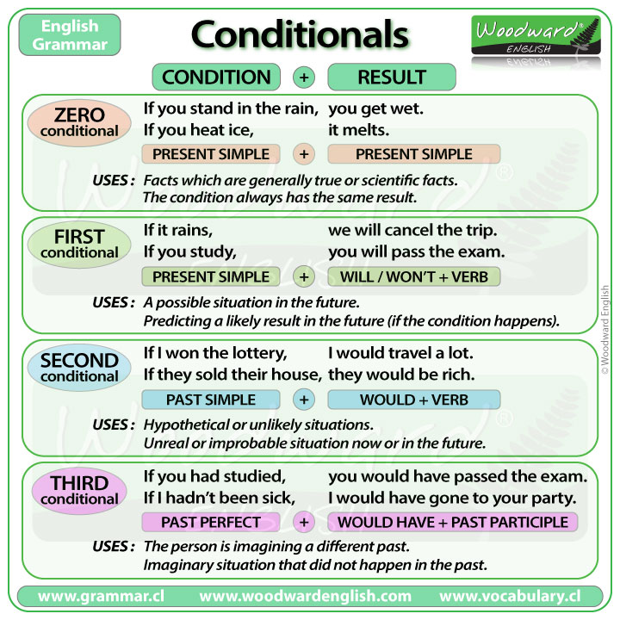

Explanation: https://www.perfect-english-grammar.com/second-conditional.html

Video:
https://www.youtube.com/watch?v=71u-NoY4Ag8 (simple)

https://www.youtube.com/watch?v=SnMTX56wYCM (not required… but if you’re curious to find out more!)

Reading
- Intergenerational schools

Conversation Questions

- What's your favorite city in Korea? Why?
- If you could live anywhere in Korea, where would choose to live?
- When you want to celebrate (end of semester, birthday, other special events) where do you most like to go? Why?
- What is the cost of living like in Korea? Explain.
- If you had a lot of money, how would you spend it?
- If you could have any job, what would it be? Why?
- How could you best prepare yourself to get the job you want?
- Is the crime rate high in Korea? What crimes are common?
- What do you think about crime in other countries (USA, for example)?
- What social problems are you worried about? How might you solve them?

